- The most basic figures in geometry are undefined terms, which cannot be defined by using other figures. The undefined terms point, line, and plane are the building blocks of geometry.
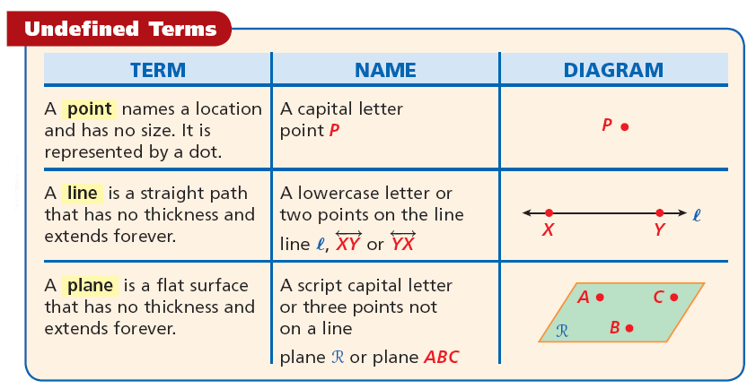
- Points that lie on the same line are collinear. K, L, and M are collinear. K, L, and N are noncollinear. Points that lie on the same plane are coplanar. Otherwise they are noncoplanar.
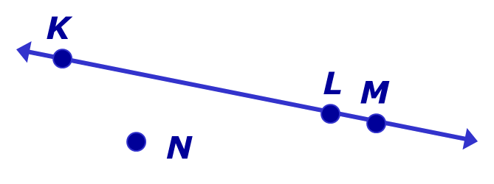

EX 1:
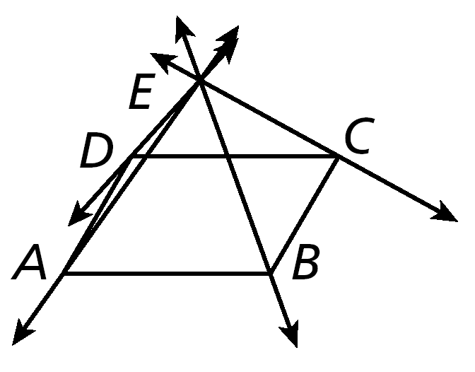
A. Name four coplanar points.

B. Name three lines.
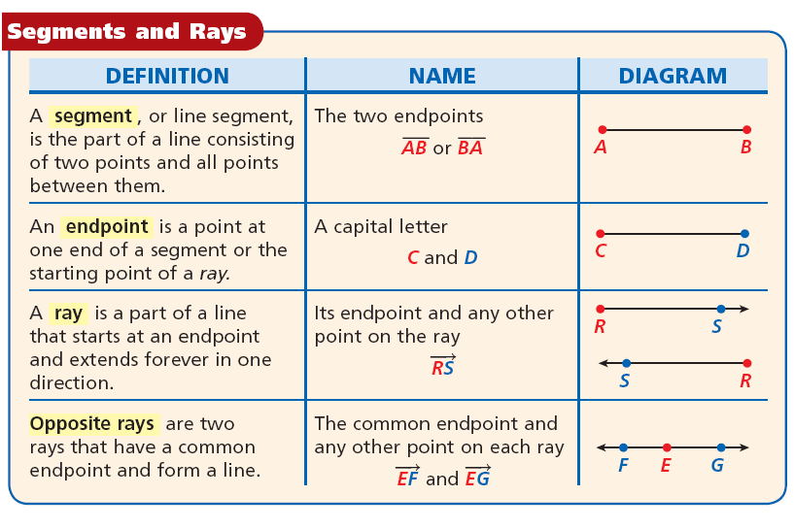
EX 2: Draw and label each of the following.
- a segment with endpoints M and N.

- opposite rays with a common endpoint T.

EX 3: Draw and label a ray with endpoint M that
contains N.

- A postulate, or axiom, is a statement that is accepted as true without proof. Postulates about points, lines, and planes help describe geometric properties.

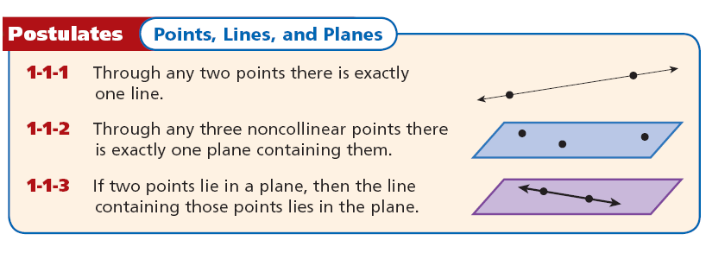
EX 4: Name a line that passes through two points.
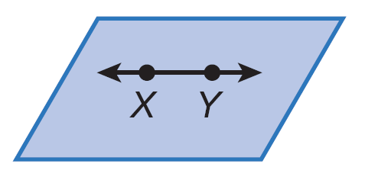

EX 5: Name a plane that contains three noncollinear points.
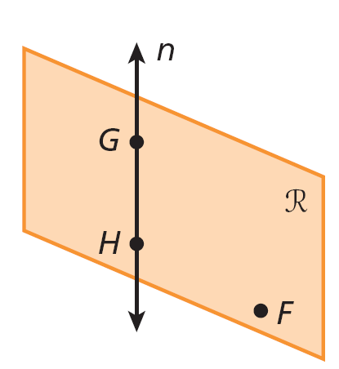

- An intersection is the set of all points that two or more figures have in common. The next two postulates describe intersections involving lines and planes.
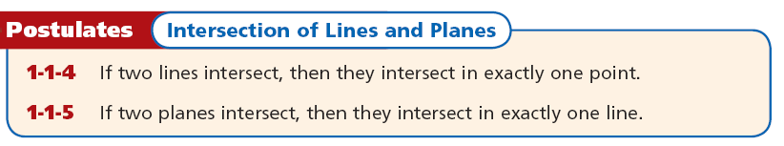
- Use a dashed line to show the hidden parts of any figure that you are drawing. A dashed line will indicate the part of the figure that is not seen.
EX 6:
- Sketch two lines intersecting in exactly one point.

- Sketch a figure that shows a line that lies in a plane.

EX 7: Sketch a figure that shows two lines intersect in one point in a plane, but only one of the lines lies in the plane.

WARM UP:

