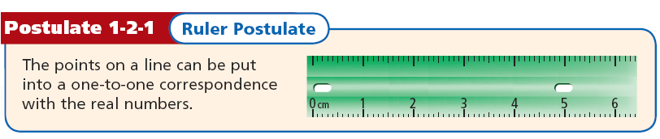

- The distance between any two points is the absolute value of the difference of the coordinates. If the coordinates of points A and B are a and b, then the distance between A and B is |a – b| or |b – a|. The distance between A and B is also called the length of AB, or AB.
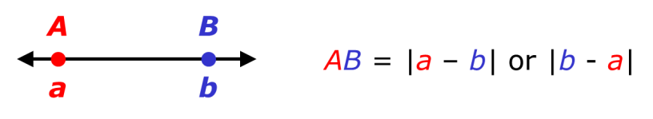

EX 1: Find each length.

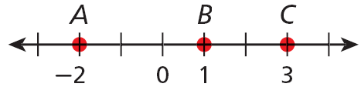
A. BC B. AC

EX 2: Find each length.

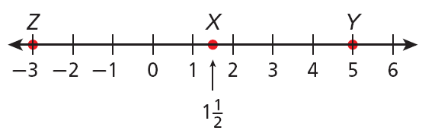

a. XY b. XZ

- Congruent segments are segments that have the same length. In the diagram, PQ = RS, so you can write PQ ≅ RS. This is read as “segment PQ is congruent to segment RS.” Tick marks are used in a figure to show congruent segments.
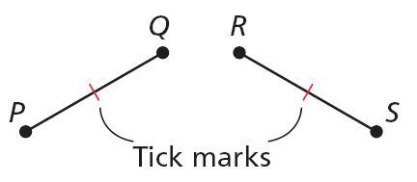

- You can make a sketch or measure and draw a segment. These may not be exact. A construction is a way of creating a figure that is more precise. One way to make a geometric construction is to use a compass and straightedge.

EX 3: Sketch, draw, and construct a segment congruent to MN.

- In order for you to say that a point B is between two points A and C, all three points must lie on the same line, and AB + BC = AC.
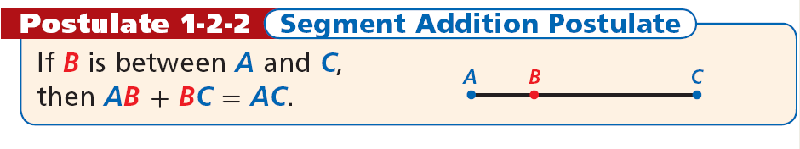
EX 4: G is between F and H, FG = 6, and FH = 11. Find GH.

EX 5: M is between N and O. Find NO.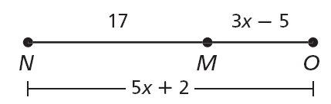

EX 6: E is between D and F. Find DF.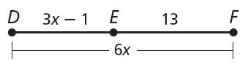

- The midpoint M of AB is the point that bisects, or divides, the segment into two congruent segments. If M is the midpoint of AB, then AM = MB.
- So if AB = 6, then AM = 3 and MB = 3.
EX 7: D is the midpoint of EF, ED = 4x + 6, and DF = 7x – 9. Find ED, DF, and EF.

EX 8: S is the midpoint of RT, RS = –2x, and ST = –3x – 2. Find RS, ST, and RT.

WARM UP:

