* An **angle** is a figure formed by two rays, or sides, with a common endpoint called the **vertex** (plural: *vertices*). You can name an angle several ways: by its vertex, by a point on each ray and the vertex, or by a number.
* The set of all points between the sides of the angle is the **interior of an angle**. The **exterior of an angle** is the set of all points outside the angle.

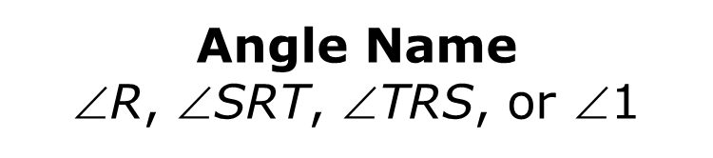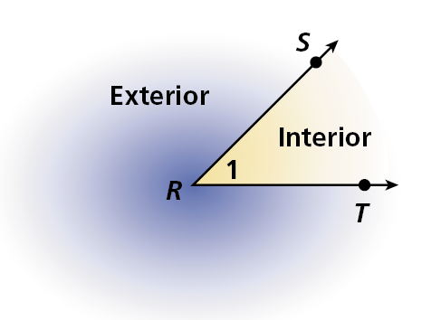

* You cannot name an angle just by its vertex if the point is the vertex of more than one angle. In this case, you must use all three points to name the angle, and the middle point is always the vertex.

**EX 1:** You cannot name an angle just by its vertex if the point is the vertex of more than one angle. In this case, you must use all three points to name the angle, and the middle point is always the vertex.

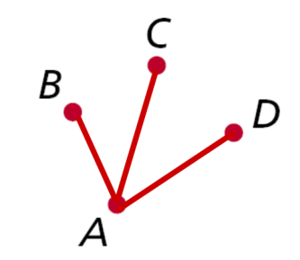

**EX 2:** **Write the different ways you can name the angles in the diagram.**

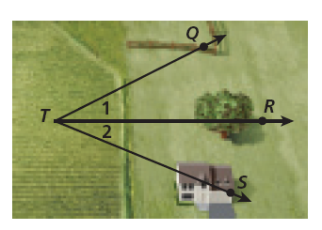

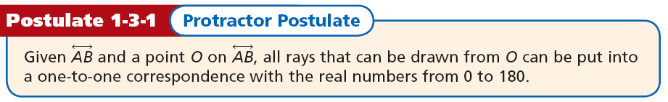

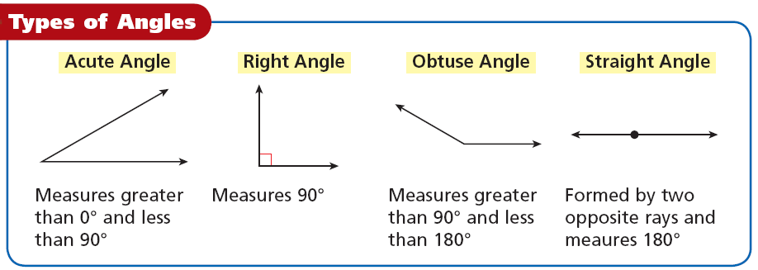

**EX 3:** **Find the measure of each angle. Then classify each as acute, right, or obtuse.**

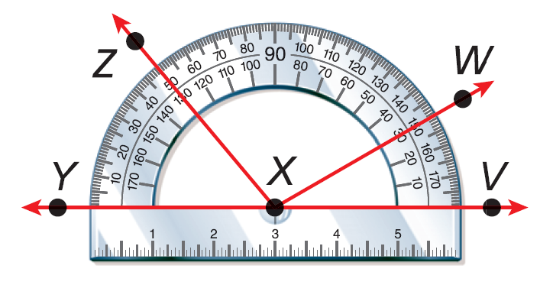

**A. ∠***WXV* **B. ∠***ZXW*

* **Congruent angles** are angles that have the same measure. In the diagram, m∠*ABC* = m∠*DEF*, so you can write ∠*ABC* ≅ ∠*DEF*. This is read as “angle ABC is congruent to angle *DEF*.” *Arc marks* are used to show that the two angles are congruent.

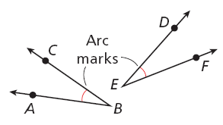

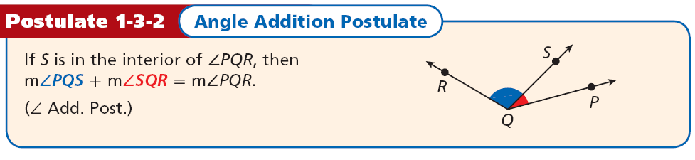

**EX 4:** **m∠*DEG* = 115°, and m∠*DEF* = 48°. Find m∠*FEG***



**EX 5:** **m∠*XWZ* = 121° and m∠*XWY* = 59°. Find m∠*YWZ*.**

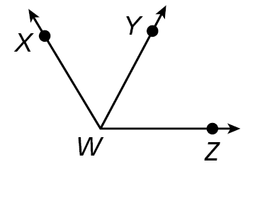

* **An angle bisector is a ray that divides an angle into two congruent angles.**

***JK* bisects** ∠***LJM*; thus** ∠***LJK*** ≅∠***KJM.***

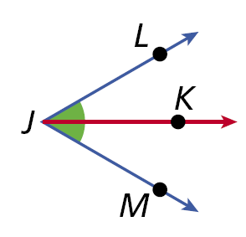

**EX 6: *KM* bisects** ∠***JKL*, m**∠***JKM* = (4*x* + 6)°, and m**∠***MKL* = (7*x* – 12)°. Find m**∠***JKM*.**



**EX 7: Find the measure of each angle. *QS* bisects ∠*PQR*, m∠*PQS* = (5*y* – 1)°, and m∠*PQR* = (8*y* + 12)°. Find m∠*PQS*.**

**WARM UP:**