- The perimeter P of a plane figure is the sum of the side lengths of the figure.

- The area A of a plane figure is the number of non-overlapping square units of a given size that exactly cover the figure.
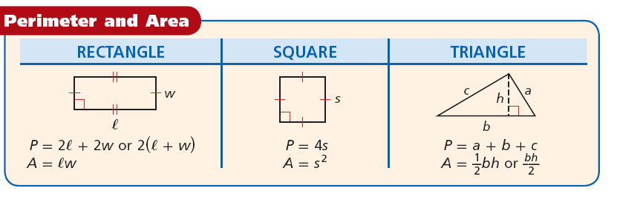
- The base b can be any side of a triangle. The height h is a segment from a vertex that forms a right angle with a line containing the base. The height may be a side of the triangle or in the interior or the exterior of the triangle.
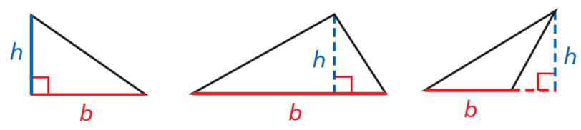

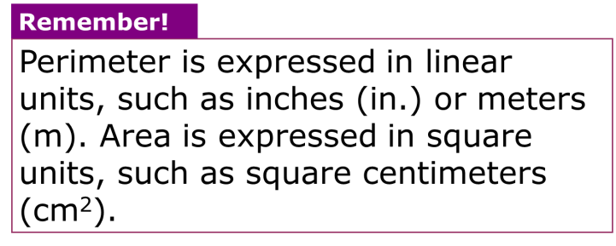
EX 1: Find the perimeter and area of each figure.
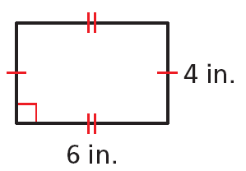

EX 2: Find the perimeter and area of each figure.
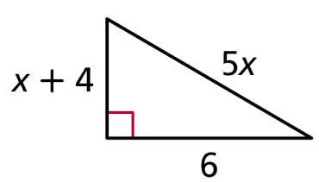

EX 3: Find the perimeter and area of a square with s = 3.5 in.

- In a circle a diameter is a segment that passes through the center of the circle and whose endpoints are on a circle. A radius of a circle is a segment whose endpoints are the center of the circle and a point on the circle. The circumference of a circle is the distance around the circle.
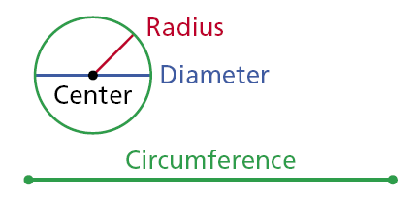
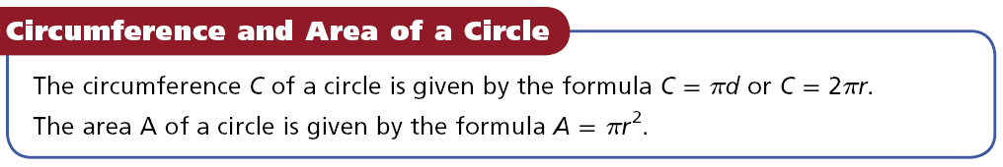
- The ratio of a circle’s circumference to its diameter is the same for all circles. This ratio is represented by the Greek letter π (pi). The value of π is irrational. Pi is often approximated as 3.14 or 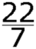 .

EX 4: Find the circumference and area of a circle with radius 8 cm. Use the π key on your calculator.
Then round the answer to the nearest tenth.

EX 5: The area of a rectangle is 74.82 in2, and the length is 12.9 in. Find the width.

WARM UP:

